- Use Case diagram for ATM system, with use case specifications.

Specifications:

- Insert the ATM card properly
- ATM card is not inserted properly – the system will show “The card has not been inserted properly”.
- Entering valid PIN number
- PIN number not entered properly – the system will show “Enter the valid PIN number”.
- Incorrect PIN number entered 3 times – the system will show “Your card has been blocked temporarily”.
- PIN number has not been entered for a long time – the system will show “Session expired”.
- Clicking the CANCEL button after entering valid PIN number – the system will show “Your last transaction has been cancelled”.
- Successful selection of language of operation.
- Successful selection of account type.
- Incorrect bank account type selection – leads to unsuccessful operation.
- Select the type of operation successfully – withdraw amount.
- Clicking the CANCEL button after selecting the type of transaction – the system will show “Your last transaction has been cancelled”.
- Entering the correct amount of money to be withdrawn.
- Cash dispensed successfully.
- The receipt showing the transaction has been printed.
- The money to be withdrawn has not been entered with correct denominations – the system will show “The amount should be multiples of 100”.
- Entering the amount of money exceeding the day limit – leads to unsuccessful operation. The entered amount of money can’t be dispensed.
- Entering the amount that is greater than the amount in the bank account – money can’t be withdrawn
- The amount need to withdraw has not entered for long time – the system will show “Session expired”.
- The amount need to be withdrawn has not available in the ATM system – the system asks the user to select different amount.
Use case Diagram

Use case diagram represents the interaction of the user with the system. Represents the relationships among actors and usecases.The purpose of use case diagram is to capture the dynamic aspect of a system.

Common uses:

- Used to gather the requirements of a system.
- Used to get an outside view of a system.
- Identify the external and internal factors influencing the system.
- Show the interaction among the requirements are actors.
Symbols
Symbol | Representation | Description
Actor | 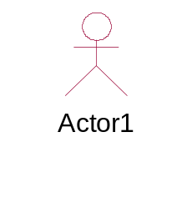 | An actor specifies a role played by a user or any other system that interacts with the subject.  Primary, Secondary Actors will be there.
Use case | 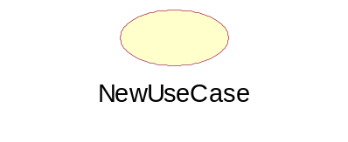 | Describes set of actions done by the actor

